**RESUME**

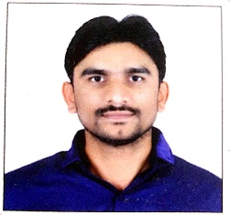

**Name:- SURYAWANSHI MAROTI SHAMRAO**

**Personal Details:**

**Mobile No. 7030349181**

**Email:** [**marotisuryawanshi25@gmail.com**](mailto:marotisuryawanshi25@gmail.com)

**DOB: 25/04/1989**

**Gender: Male**

**Nationality: Indian**

**RELIGION: Hindu**

**LANGUAGES KNOWN: Marathi, English, Hindi**

**ADDRESS: At. Post. Kandali Tq. Bhokar**

**Dist. Nanded Pin : 431801**

**Career Objective**

To being my teaching career at an esteemed institution to build strong teacher profile and help students to become globally competitive through developing their skills.

**Qualification**

|  |  |  |
| --- | --- | --- |
| **Examination** | **Name of board & University** | **Year** |
| **SSC** | **LATUR** | **2004** |
| **HSC** | **LATUR** | **2007** |
| **D.ED** | **PUNE** | **2009** |
| **B.A** | **YCMOU** | **2012** |
| **M.A(Political sci)** | **SRTMU** | **2014** |
| **B.ED** | **SRTMU** | **2015** |
| **MS-CIT** | **MUMBAI** | **2008** |

**Professional Skills**

**Have excellent** communication & instructional skills .

Ability to teach in English, Marathi, Hindi.

Working knowledge with computers & internet.

Can plan and execute in class and outdoor educational activities & events.

**Hobbies:**

Reading books

Driving

Writing

Playing cricket, holly boll

Declaration:

I here by declare that all the above information is true to the best of my knowledge.

Place:Nanded 

Date: Signature